MOLECULAR NETWORKS
Part II: A Systems Approach to Studying the Bacteriorhodopsin Network in Halobacteria

Background

A Network is defined as a system of distinct members that are associated or related through the particular relationships that connect them. The members of a network are referred to as nodes and are most commonly represented by circles, while the relationships between members are referred to as edges and are represented by the arrows that connect them. Depending on the relationship being represented between the members in the network the edges may be diagrams with arrow at one or both ends.
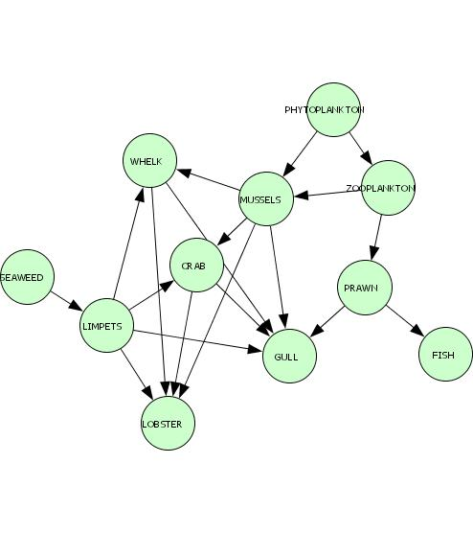
In order to develop the skills for understanding biological networks, you will be expanding your understanding of the expression of bacteriorhodopsin in halobacteria through analyzing data from a number of perspectives including molecular homology, biochemistry (chemical reactions), and gene expression profiling (microarray).

Acknowledgements

My interest in teaching about systems biology was initially inspired by the book The Music of Life by Denis Nobel, and this activity was modified from those developed by the Baliga Laboratory at the Institute for Systems Biology in conjunction with the Bellevue School District.

Procedure

Group Study and Presentation

1. After you have collected your data from part I of the Halbacteria Network, your group will be assigned a particular systems perspective (homology, metabolism, or microarray). Each of these perspectives contains its own background, data (and possibly instructions), and questions. It is your groups job to read the background, interpret the data, and answer the questions with the goal of better understanding the halobacteria network involving bacteriorhodopsin.

2. After completing your group questions, read the background and data assigned to the other groups. When all groups are finished with their analysis, each will have the opportunity to teach the other groups (this should be done such that they can answer the questions for your perspective as well).

Completing the Network using a Systems Biology Approach

1. Re-copy the network presented to you by the Biochemical Metabolic group on a separate piece of paper.

2. The edges in the metabolic network indicate enzymes that catalyze those reactions. Use the Molecular Homology group’s data to label the edges with the name of the appropriate enzyme.

3. Draw a circle as an additional node to represent the gene for bat. Draw arrows from bat to the enzymes that it influences. Indicate if the relationship between bat and the enzymes is positive (+) or negative (-).

4. Draw light as an additional node in the network. If you hypothesize that light has a relationship with any of the other nodes in the network, draw an edge between light and any of those nodes. Indicate with an edge whether light has a positive (+) or negative (-) affect on any of those nodes.

5. Re-draw your entire network so that it is presented the knowledge it contains in the most efficient manner. While doing, so give attention to the following prompts.

a. Edges: Does the arrow from GG-PP to phytoene mean the same thing as the arrow from bat to CrtB1? If the arrows have different meaning, identify them with different symbols.

b. Nodes: Is GG-PP the same type of node as bat? If the nodes have different meaning, identify them with different symbols.

Make a key or legend to indicate what the different symbols in your network mean.

MOLECULAR HOMOLOGY PERSPECTIVE

Background

Your goal is to determine relationships between proteins that define the cellular network. In order to do this your group will analyze data obtained from homology searches.

Scientists are working to determine relationships between proteins by compiling all available information about the genes and proteins in a network into a very large database. The gene sequences for genomes of many organisms have been added to this database. A genome is an organism’s entire sequence of DNA; therefore, if the DNA sequence is known, the proteins can be predicted (recall DNA → mRNA → protein).

For many genes, functions and properties have been determined in the laboratory. But for many other genes and proteins, scientists use this database to help them make hypotheses about the functions and properties of these genes and proteins. Scientists compile what is known about the genes and proteins in the network of interest. Then they analyze the information to hypothesize relationships between the proteins. Information about genes with unknown functions can be predicted by comparing their sequences to genes in the database that have known functions and properties.

Searching for homologous genes, genes with similar sequences, is called homology searching. Similar nucleotide sequences will result in proteins that have similar shapes and folding patterns. Homologous proteins that are similar in their 3-dimensial shape will have similar properties and functions. Homologous proteins are proteins that perform the same function in two different organisms. For example, the hemoglobin protein that carries oxygen in the blood of a cow is homologous to the hemoglobin protein in humans.

Information obtained from homology searching can help scientists determine if the protein they are studying is an enzyme, a membrane-associated protein, or a transcription regulator. Scientists can then study the protein’s role in the network more specifically. Scientists can also determine what kind of regulatory sequences exist in the DNA that will affect the transcription of the gene that codes for the protein. Ultimately, all this information helps scientists determine how a protein interacts in a metabolic network.

Data

Gene  name | Protein  type | Description | "UAS" regulatory sequence in promoter
crtB1 | enzyme | Substrate: GG-PP, Product: phytoene | Yes
crtY | enzyme | Substrate: lycopene, Product: beta-carotene | No
brp | enzyme | Substrate: beta-carotene, Product: retinal | Yes
bop | membrane-  associated | Combines with retinal to form bacteriorhodopsin (bR), a membrane protein that pumps H⁺ ions out of the cell using energy from sunlight. The H⁺ ion concentration gradient is used to produce ATP | Yes
bat | transcription  regulator | Binds DNA at sequences called "UAS" and increases transcription by binding to RNA polymerase or related transcription proteins.  Oxygen affects activity of bat.  Light affects activity of bat. | Yes

Gene name:
Gene names are often written in italics; the protein coded by the gene is often written in regular font. For example, crtB1is the gene that codes for the crtB1 protein.

Protein type:
Enzymes convert specific substrates into products; membrane-associated proteins are found near or in the cell membrane; and transcription regulators are proteins that control the amount of mRNA transcription by binding to RNA polymerase and regions of DNA in particular genes.

Description:
Information about known functions for each of the proteins. For enzymes, S: means substrate and P: means product.

“UAS” regulatory sequence in promoter:
Some genes have activator sequences in their promoters called “Upstream Activator Sequences”. Transcription regulator proteins bind to the UAS and RNA polymerase to increase the amount of mRNA transcription.

Questions

- Which protein is likely the sensor that detects the presence of light and oxygen? What specific information in your data table suggests this?

- What does UAS mean? Which protein binds to UAS and how does binding affect the amount of transcription of genes with a UAS?

- From the lab, how did the amount of light affect the amount of bacteriorhodopsin in halo?

- Fill in the spaces below using the information provided on the Homology Data Table. Fill in the gene name (protein) that catalyzes each reaction.

bacteriorhodopsin
Protein
lycopene
beta-carotene
retinal
GG-PP
phytoene
Protein
Protein
Protein
ATP

- Thinking of your responses to the above questions, suggest a hypothesis for how the network is regulated in response to light and oxygen. You can explain your hypothesis with a diagram in addition to words.

- What data/information would help you test the hypotheses or support or refute these hypotheses you suggested in question #8?

BIOCHEMICAL METABOLIC PERSPECTIVE

Background

Your group is responsible for analyzing data obtained from biochemical pathways. Your goal is to determine relationships between proteins that define the cellular network.
2H₂O2H₂ + O₂
(Input)
(Outputs)
Reaction
(change)

Chemical Reaction:

Biochemistry is the study of the structure and function of cellular components, such as proteins, carbohydrates, lipids, nucleic acids, and other biomolecules and the reactions that take place within cell. In order to study the complex chemical structures and reactions that make a living organism, scientists and scholars use a mixture of both biology and chemistry.

In biochemistry, a metabolic pathway is a series of chemical reactions occurring within a cell, catalyzed by enzymes, resulting in either the formation of a metabolic product to be used or stored by the cell, or the initiation of another metabolic pathway. Many pathways are elaborate, and involve a step by step modification of the initial substance to shape it into the product with the exact chemical structure desired. Since all life forms on Earth today are believed to have come from a common ancestor, all life has similar biochemical pathways. Although there is a large number of different biomolecules, they tend to be composed of the same repeating subunits, in different orders. Placing these large numbers of subunits into large networks called biochemical pathways, allows scientists to study how the complex chemical structures interact and allow the cell to change due to its environment.

In order to build a biochemical pathway several things need to be done. First, scientists identify the inputs and outputs of the overall reaction. Secondly, the scientists break down the overall reaction into likely elementary steps. Then looking at all of the experimental data that is available, along with some chemical reaction knowledge, scientists hypothesize possible intermediates in the overall reaction. Experiments are run using mathematical models and laboratory research, which allow the scientists to continue to refine and improve the pathway, testing it against all new experimental results.

Biochemical pathways are used in many different areas of science including genetics, molecular biology, agriculture and medicine. Probably one of the first uses of biochemistry was the making of bread using yeast, approximately 5000 years ago.
Instructions

Below, you are given various metabolic reactions that occur in halobacteria. You will analyze this variety of chemical reactions and determine how the reactions are connected in the bacteriorhodopsin (bR) network. The reactions on the data sheet are not necessarily in the right order. Your goal is to determine how light increases the expression of bacteriorhodopsin.

- Given the various reactions on the data sheet, draw the substrates (inputs) and products (outputs) as nodes in a network.

For example, given the following reaction

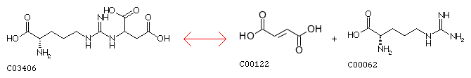
L-arginosuccinate
arginine

…you would draw the following

L-arginosuccinate

arginine
*Notice that even though there is another product in the reaction, only the product that is labeled in the data sheet, arginine, is drawn in the network.

- Continue drawing all of the reactions from the data sheet. Make connections by drawing edges where the output of one reaction is the input of another reaction. Make sure you do not have duplicate nodes!

Data
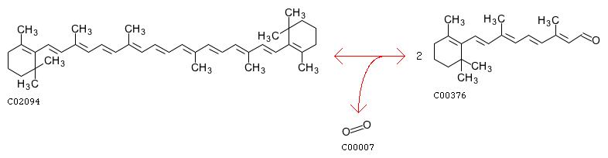
Beta-carotene
Retinal
Substrate: beta-carotene→Product: Retinal
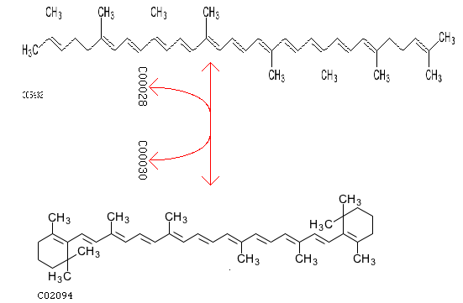
Beta-carotene
Lycopene
Substrate: Lycopene→Product: Beta-carotene
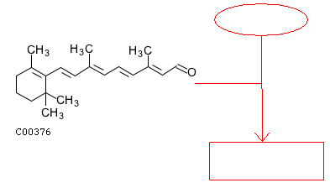
BOP Protein
Bacteriorhodopsin
Retinal
Substrate: Retinal and BOP protein→Product: Bacteriorhodopsin
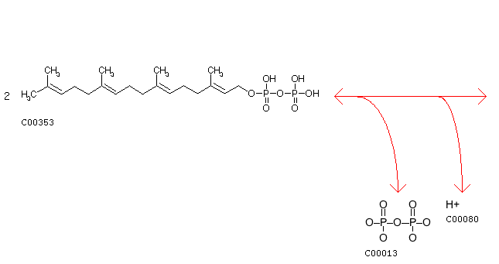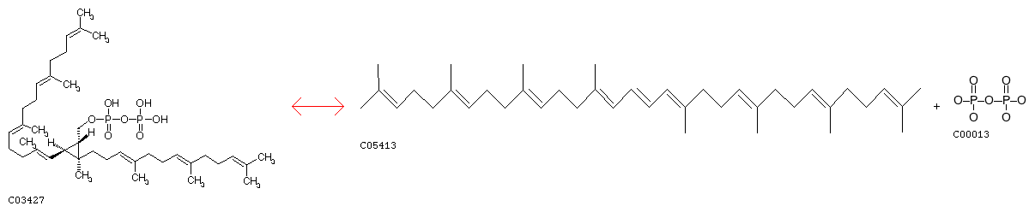
GG-PP
Phytoene
Substrate: GG-PP → Product: Phytoene

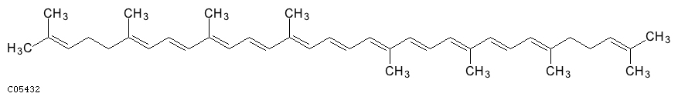
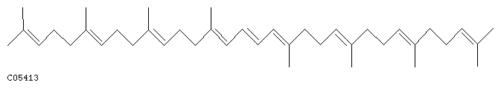
Phytoene
Lycopene
Substrate: Phytoene → Product: Lycopene

Questions

- Diagram your complete network in the space below.

- In a metabolic network, what do the nodes represent? What do the edges represent?

- What would happen to the network if there were more GG-PP? How would this affect the amount of bacteriorhodopsin produced? Explain your reasoning.

- What would happen to the network if the amount of lycopene decreased? How would this affect the amount of bacteriorhodopsin produced? Explain your reasoning.

- If the reaction that converts phytoene to lycopene were not able to occur, how would the amount of bacteriorhodopsin (BR) be affected? Explain your reasoning.

- How is the amount of product controlled in the network? What do you think might regulate the network? Are all the reactions occurring at the same time in the cell at all times?

- Thinking of your answers to the questions above, suggest a hypothesis for how the bacteriorhodopsin network is regulated. What data/information would help you test your hypothesis or support or refute this hypothesis?

MICROARRAY PERSPECTIVE

Background

Your group is responsible for analyzing data on gene expression. Your goal is to determine relationships between proteins that define the cellular network.

One way to determine relationships between proteins is to change the amount of one protein in the cell and see how others are affected. Individual proteins can be removed from the cellular network by “knocking out” the gene for that protein. By mutating or removing the gene from the chromosome, the mRNA cannot be transcribed, and the protein will not be made in the cell. Related procedures can be used to make the cell constantly produce a particular protein much more than normal. This is called “overexpression.”

We can measure the effects of knocking out or overexpressing particular genes by measuring the changes to the amounts of other proteins compared with the normal strain. The amount of protein transcribed from a gene is called the “expression” of the gene.

If the amount of protein is more than normal, it has higher or greater expression. We indicate this affect with a (+). If the amount of protein is less than normal, it has lower expression. We indicate this with a (-). If the amount of protein is the same as normal, it has the same expression. We indicate this with a (0).

Measuring the amount of mRNA often correlates with amount of protein present because the protein is coded by mRNA (remember the Central Dogma: DNA → mRNA → protein). We can measure mRNA using microarray technology.

You may want to view the following animations for more information on microarray technologies:
http://www.bio.davidson.edu/Courses/genomics/chip/chip.html

Instructions

Your goal is to determine relationships that define and regulate the bacteriorhodopsin (bR) network. Ultimately, we want to determine how light increases the expression of bacteriorhodopsin.

brp

bop
crtB1

crtY
bat

Draw an arrow from bat to the genes that it influences. Indicate how bat affects the expression of these genes by adding (+) for positive relationships and (-) for negative relationships next to your arrows. (Positive = gene expression increases when bat is over-expressed or gene expression decreases when bat is knocked out. Negative = gene expression decreases when bat is over-expressed or gene expression increases when bat is knocked out.)

Data
 | Different strains of Halo
 | Overexpress bat  (bat +) | Knockout bat  (bat-) | Knockout bop  (bop-)
crtB1 | + | - | same as normal
crtY  Gene  name | same as normal | same as normal | same as normal
bop | + | - | -
brp | + | - | same as normal
bat | + | - | same as normal

Figure legend: The first column lists the names of various genes in halobacteria. The remaining 3 columns represent data for 3 different strains of halobacteria made in laboratory (+ means greater expression than normal, - means less expression than normal, and ‘same as normal’ means there is no difference in expression compared with the normalstrain).

In the bat+ strain, the bat gene is overexpressed; in the bat- strain, the bat gene is knocked out; and in the bop- strain, the bop gene is knocked out. Each row represents the expression level of a different gene in the three strains compared to normal.

For example, the first row shows that the expression of the gene crtB1 is greater than normal in the strain of halobacteria with bat overexpressed, less than normal when bat is knocked out, and is no different from normal when bop is knocked out.

Questions

- How does bat affect the expression of these genes?

- What would happen to the genes if bat were over-expressed? (make sure to discuss bat’s influence on all genes)

- What does this suggest about bat’s role in regulating the bR network?

- How do the expression levels of the genes in the bop knockout strain compare to the normal strain?

- What does this suggest about how bop affects expression of the different genes?

- What does this suggest about bop’s role in regulating bR?

- You just suggested hypotheses for the roles of bat and bop in the regulation of the other genes (Questions 3 and 6). What data/information would help you test these hypotheses or support or refute these hypotheses?

Pre-Lab Pre-Assessment Questions

- What is the purpose of enzymes within the cell? What determines the shape of the enzyme? Why is the shape important?

- Think back to the lactase enzyme lab with milk and glucose test strips. The enzyme lactase breaks lactose into glucose. Draw this enzyme reaction below using two nodes connected with an edge.

- What allows some genes to be expressed differently from one another? In other words, how are genes turned “on” and “off”?

- In what ways do cells respond to their environment, and how do they change internally to respond? Give a specific example.

- How do different parts of the cell function together as a network of nodes and edges?

- How could a change in one of these nodes affect other nodes in the network?

- We often represent cells as networks. Hoes does a network approach help us understand how cells function?

8. Why do scientists need to analyze multiple types of data from different expert groups when figuring out how cells function?

