Objectives:
- Discover some effects of increasing CO₂ in the atmosphere.
- Determine the environmental factors that impact populations of coccolithophores and silica-shelled algae.
- Discover the role methane hydrate reservoirs play in ocean pH.

Description:
As learned throughout this module, Phytoplankton are organisms responsible for about 40 percent of the total photosynthesis that occurs in our planet and play a critical role in the global carbon cycle and ultimately in global climate. This model simulates the effects of varying amounts of CO2 on the population of the primary producer coccolithophore and a silica-shelled algae that provides carbohydrates to the food chain. The amount of CO2 affects the nodes in this simulation without detailing the various mechanisms in the system that cause the changes in populations. Both are affected in different ways. In Lesson 6 there are continued opportunities to research and explore how what is seen in the simulated Ocean Acidification model might come about. This simulation model and the additional research closely follow the experiences scientists go through as they search for deeper understanding of something observable in the laboratory.

Student practice with given parameters and then design their own experiment so answers will vary.
Answer the following questions to assess your prior knowledge: Then check your responses by referring to links provided.
- Where is carbon stored in the earth system? (Hint: Carbon Cycle)
- How is carbon used by phytoplankton such as coccolithophores or Thap?
- Where is carbon stored in the ocean system? (Hint: Carbon Cycle)
- What process is transferring carbon from atmosphere to living ocean organisms?
- What are sources of CO2 that contribute to the ocean water acidification?(Hint: Carbon Cycle)
- How does CO2 transfer into the ocean water? (Hint: Carbon Cycle)
- What are methane hydrate reservoirs ?
- What are coccolithophores? What role do they play in the ocean system?

Check in: Draw a system diagram to show the interactions among the various nodes that you will be exploring in the following model ( use the information from above to help you):

(Example)

CO2

Methane hydrates
CO2
O2
O2
H2CO3
H2CO3
H2CO3

Decompose
Methane hydrates
Thaps (diatoms or algae)
Decompose
CO2
CO2
O2
O2

CO2
O2

Coccolithophores
O2
CO2

Instructions: How to set-up the Ocean Acidification Netlogo Simulation model

Step 1. Open the NetLogo program using the NetLogo website. Download this Ocean Acidification.nlogo file by right clicking the link and selecting "Save As” or “Download As." Save it to a NetLogo folder on your Desktop. Or find the .nlogo file saved in a public folder by your teacher. On the Netlogo website link click “Go to Netlogo Web” When the window opens click on “Choose File”. Browse and choose Ocean Acidification.nlogo file (saved to your Netlogo folder). Go to Step 2, and follow instructions to start investigating with the model.

Step 2. Click ‘Setup’. Click on ‘Add CO2” as many times as it takes to increase the Atmospheric CO₂ (ppm) to 400 or a bit more (current concentration). Use the slider to set the methane hydrate reservoir size to around 800. Click “Go” and let the time (based on ‘ticks’) run to about 1400 and then press the "Go” button again to stop the simulation.

Example:
Parameters  (Time at 1400) | Carbonic Acid in Ocean | Methane Hydrates | pH in ocean | Cocco-lithophore  count | Algae  count
CO₂ at 400; methane hydrate reservoir at 806 | 83 | 74 | 8.2121 | 61 | 46
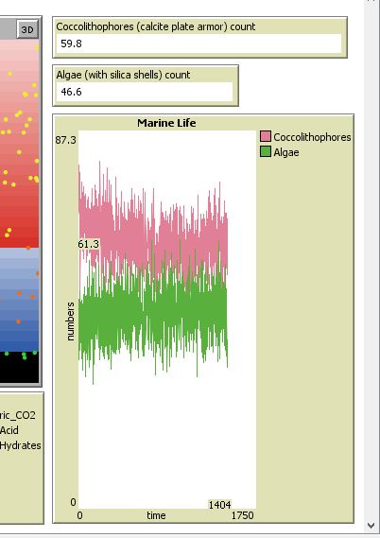
Step 3. Change only your CO₂ and keep your methane hydrate reservoir around 800 to fill in the following table:

Hint:
Drag cursor over the pink section of the Marine life graph to obtain a precise count.
Response to Changing Atmospheric CO2
Parameters  (Time at 1400) | Carbonic Acid in Ocean | Methane Hydrates | pH in ocean | Cocco-lithophore  count | Algae  count
CO₂ at ____; methane hydrate reservoir at _____
CO₂ at ____; methane hydrate reservoir at _____
CO₂ at ____; methane hydrate reservoir at _____
CO₂ at ____; methane hydrate reservoir at _____
CO₂ at ____; methane hydrate reservoir at _____
Step 4. After recording your last row of data. Lower the methane hydrate reservoir to 50 (use slider) and click ‘Go’. What happens to the populations?
Methane is released from the reservoir leading to more CO₂ in the ocean and a drop in pH.

Step 5. Experiment with the parameters until you find the set that results in coccolithophore and algae counts reversing (looking opposite). Describe the ‘environment’.
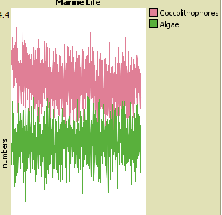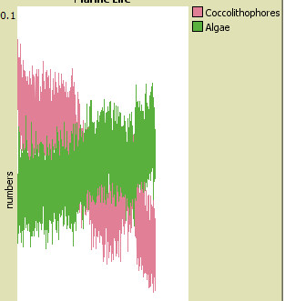
CO₂ increased to 1000 combined with Methane at high level causes a reverse. Methane is building up in the reservoir, because of the increase in CO₂ coming from the atmosphere leading to more Carbonic Acid in the ocean and a drop in pH.
Step 6. What claims can you make about the relationship between the amount of CO₂ and the methane hydrate reservoir?

Methane is added to the reservoir when CO₂ increases in the ocean.
Provide evidence for your claims:

Methane_Hydrates are increasing in the reservoir as are Carbonic_Acid levels in the ocean. When CO₂ levels are increased in the system, this change correlates with the gradual decrease in CO₂ in the atmosphere.
Step 7. What claims can you make about the relationship between the amount of CO₂ and the ocean pH?
pH began to decrease as the amount of Carbonic_Acid levels increased in the ocean.
Provide evidence for your claims:
When CO₂ levels are increased in the system overall the Carbonic_Acid in the ocean increases and the Methane_Hydrates also increases. The ocean pH decreases and becomes more acidic as more Carbonic Acid is present in the ocean.

Step 8: What are the consequences you can predict from the model as CO₂ increases? What will this do to populations of coccolithophores? And algae? How will this affect the other nodes in the system? Explain your answer, naming at least three specific nodes.
When CO₂ levels increase the population of coccolithophores increases as well. Diatoms (a type of algae) will decrease. The nodes that are affected include the carbon that is passed on to other organisms that eat the coccolithophores ( food chain), the amount of carbon that is deposited into Methane hydrate reservoirs and the level of acidity and temperature of the ocean water. But if the diatoms decrease this means organisms that feed on the diatoms will also decrease, and the organisms that feed on the coccolithophores will increase. Increase in acidity affects other organisms living there that depend on the chemistry ( dissolved oxygen as an example) and nutrients available.

9. What type of data do you think was used to create the network model this simulation is based on?

The ocean acidification network model used data that was taken from ocean water samples and sample populations of organisms from several scientific studies.

