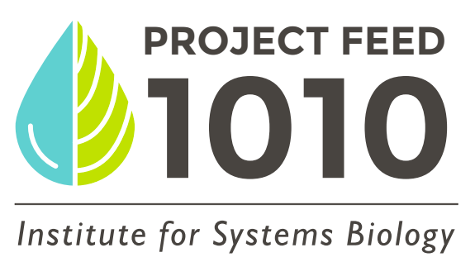
Name ___________________________________________
 |  | Date____________ | Date ____________ | Date _____________ | Date ____________ | Date ____________ | Date ____________
 | Nitrate (ppm)
 | Nitrite (ppm)
 | Hardness (ppm)
 | Chlorine (ppm)
 | Alkalinity (ppm)
 | pH
 | Total Ammonia (ppm)
 | Water Temperature (˚C)
 | Conductivity (µS/cm)
 | Number of fish pellets eaten
 | Avg plant height
 | Avg # leaves
 | Changes/annotations (added water, bacteria, ammonia, etc)

Name ___________________________________________
 |  | Date____________ | Date ____________ | Date _____________ | Date ____________ | Date ____________ | Date ____________
 | Nitrate (ppm)
 | Nitrite (ppm)
 | Hardness (ppm)
 | Chlorine (ppm)
 | Alkalinity (ppm)
 | pH
 | Total Ammonia (ppm)
 | Water Temperature (˚C)
 | Conductivity (µS/cm)
 | Number of fish pellets eaten
 | Avg plant height
 | Avg # leaves
 | Changes/annotations (added water, bacteria, ammonia, etc)

