
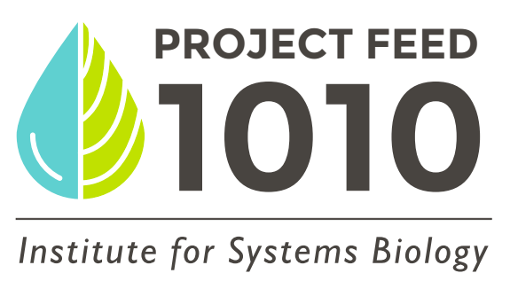
Test for | Reason to test | Solution to issue
Nitrate | Fish stressed, algae in tank | 25% water change, more plants
Nitrite | Fish stop eating/slower, ammonia present | 25% water change
Ammonia | Fish stressed | Decrease food, 25% water change
Hardness/Alkalinity | To maintain stable pH | Add hardness/alkalinity adjusting product
Chlorine | Setting up aquarium, fish stressed | Add dechlorinator or let tap water sit 48 hours before adding to tank
pH | Discolored fish, water changes | Add pH up or pH down
Testing Ammonia: Ammonia test strips
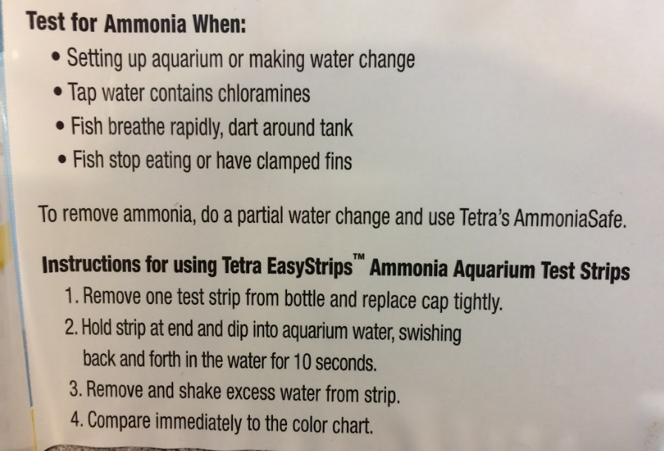
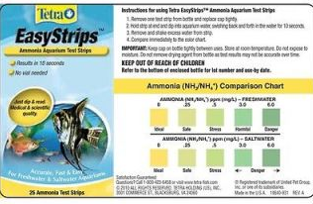

Testing nitrate, nitrite, hardness, chlorine, alkalinity, pH: 6-in-1 test strips
