Why study diatoms?

Take a break and take 5 big breaths…

That oxygen, now coursing through your body, is providing you with energy to live. One of those five breaths came from the diatoms living either near or far from you. The tiny, beautiful creatures, with their glass shells grow on the surface of our Earth’s waters – both in oceans and fresh water systems. Diatoms are the most common and abundant phytoplankton and certainly the most important food source in the sea. Since they form the base of the food web in coastal and upwelling systems, they also support important fisheries that are imperative for many economies. Due to this and many other factors, diatoms are one of the most important organisms to study when researching global carbon cycling and ocean ecosystems. Even though they only account for 1% of the world’s biomass (Falkowski, Raven, 1997), they account for 1/5th of total photosynthesis on Earth. This is more than all the worlds tropical rainforests combined! (Armbrust, 2009)

Thalassiosira pseudonana (also known as Thaps) is one large group of diatoms that we can thank for that oxygen. They are also easy to culture and will be easy for you to grow in your classroom. Thaps grow in varying nutrient and light conditions and as a result are responsible for various non-toxic blooms in our seas.
Each spring, when nutrient levels, light levels, and temperatures are high, diatom populations soar across the world. These bursts of production are referred to as blooms. The largest bloom, the North Atlantic Spring Bloom, is so big that you can see it from space! The picture at the left is of an algal bloom viewed from a satellite. You can view updated chlorophyll information online. Go to http://earthobservatory.nasa.gov/GlobalMaps/view.php?d1=MOD_LSTAD_M&d2=MY1DMM_CHLORA

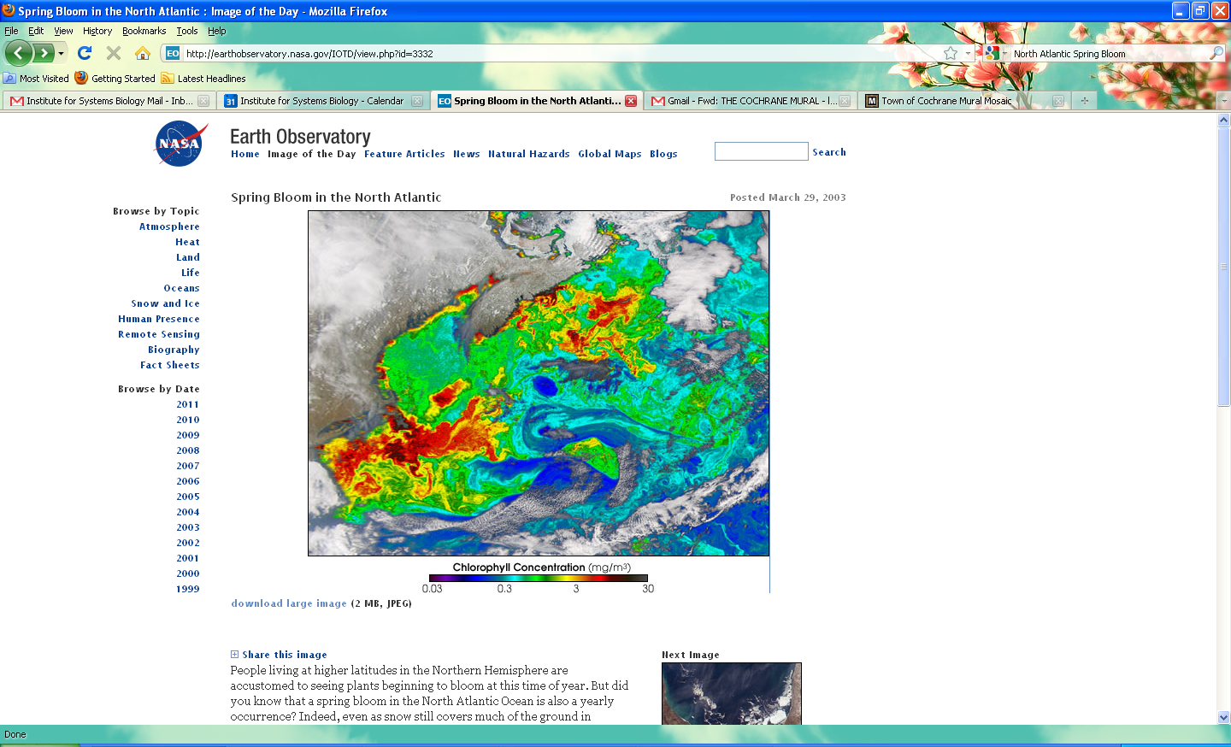

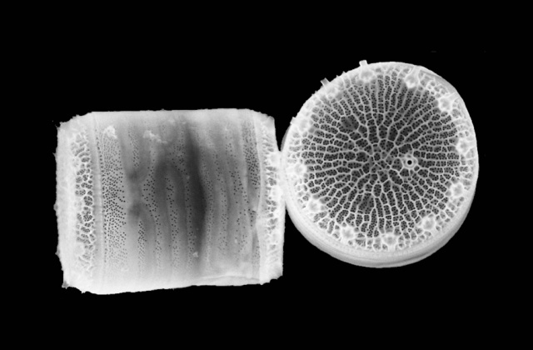
One of the ways diatoms have come to dominate primary production in the oceans is through their unique cell cycle. With each cell division, diatoms get smaller and smaller, until they reach what is called a critical minimum size. When diatoms reach this size amidst certain environmental cues, instead of dividing and reproducing asexually, they reproduce sexually. After sexual reproduction, which increases genetic diversity, the diatoms revert back to their original, large size. Because they can only reproduce sexually when they reach a certain size, sex is “spaced optimally” throughout the species, such that no energy is wasted, but diatoms are able to maintain a high genetic diversity as well as great abundance (Lewis, 1983).
Thalassiosira pseudonana: http://www.awi.de/fileadmin/user_upload/News/Press_Releases/2004/3._Quarter/Tpseudonana-2_p.jpg

What nutrients do diatoms rely on?

During these blooms, increased photosynthesis leads diatoms to sequester (i.e. hold onto, take possession of, set aside) huge amounts of CO₂. CO₂ levels have risen dramatically since the industrial revolution (from 280 ppm (parts per million) to 393), and are predicted to reach levels close to 800 ppm by the end of the 21st century. Right now, spring blooms play an important role in sequestering atmospheric CO₂, but little is known about the specific mechanisms of these blooms, and how their ability to sequester CO₂ will change as atmospheric levels continue to rise. Thus, it’s important for us to understand how diatoms bloom and what sort of conditions are required for their growth. This is needed specifically so we can make accurate predictions about the future of ocean acidification, the global carbon cycle, climate and the effect of our actions.

Diatoms have shells made of silica, and “control the biogenic cycling of silicon in the world’s oceans to such an extent that every atom of silicon entering the ocean is incorporated into a diatom cell wall on average 39 times before being buried on the sea floor” (Armbrust, 2009).

Diatoms also rely on Nitrogen and Phosphorus for their growth, and thus play a role in oceanic nitrogen and phosphorus cycles. Nitrogen is required to make amino acids – the building blocks of proteins. Organisms cannot live or function without proteins. Phosphorus is required for DNA – which is the building block of life. Diatoms are able to extract nitrogen from the ocean in many forms. They can use NO₃⁻ (nitrate), NO₂⁻ (nitrite), NH₃ (ammonia) and CO(NH₂)₂ (urea). Their ability to use these different forms of nitrogen helps them in other ways too: the urea cycle provides important proteins for building their silica shells. Samples of marine phytoplankton communities have shown that Nitrogen, Phosphorus and Silica exist in the ratio N:P:Si = 16:1:15.

Diatoms and other photosynthesizing organisms adapt to different light conditions. When there is less light, they produce more chlorophyll, enabling them to capture as much light as possible. Blooms occur in spring, after months of winter storms have mixed nutrients in the ocean. In the most intense storms in the Atlantic, waves can mix water at a depth to 200 meters!

With all this extra carbon dioxide in the environment, it may seem that diatoms will arise as “winners” in oceans showing acidification. However, we know three things. 1) An organism’s pH window is very narrow, 2) it takes species a very long time to adapt to dramatic changes in our environment, and 3) our Earth’s chemical cycles are closely interconnected. Because of this, we know to expect emergent (i.e. surprising and new) reverberating effects that will both extend from the chemical change in the ocean AND to all organisms who rely on the base of our food web. Predicting how diatoms will do is therefore very complex, very important, and requires much research.

Ideas for experiment:

How will I know that what/how I am testing is valid?

