General Information and Resources:
Scientists use ‘proxies’ to determine what ancient (can’t directly measure) climates were like. Here are some useful summations of evidence for understanding ancient climates:
http://serc.carleton.edu/microbelife/topics/proxies/general.html

http://earthobservatory.nasa.gov/Features/Paleoclimatology/paleoclimatology_intro.php

http://nature.nps.gov/geology/nationalfossilday/climate_change_past.cfm

General references such as journals:
http://www.whoi.edu/oceanus/viewTopic.do?o=read&id=1&type=11
Similar lessons:
From BSCS: http://carbonconnections.bscs.org/curriculum/unit-01/lesson-04.php
From the University of Washington: http://uwpcc.washington.edu/document.jsp?action=ViewObject&object=document&id=698&forward=no&entity=NASA&view=icon See also UW Ice Core Lab PDF

Activity Answers
Scientists look for ways to match changes in Earth’s distant past environmental conditions with the timing and speed of more recent changes. They are trying to understand how sensitive the climate system is to disruption. Various methods and tools are used to gather information.
The chemistry of seafloor sediments full of fossilized microscopic shells can reveal ocean temperatures that existed tens of thousands of years ago. (Photo by Tom Kleindinst, Woods Hole Oceanographic Institution)
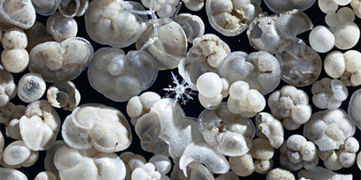
- Click here: http://www.whoi.edu/main/topic/ice-ages-past-climates , and choose 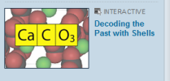
to see what scientists look for in these tiny shells.
- Which 2 elements give scientist’s clues about the nutrients available?
- Cadmium b) Carbon -13
- Why do scientists look at oxygen? O16 and O18 isotope amounts are compared to learn about seawater temps., evaporation, precipitation, river runoff, and volume of water in ice.
When ocean water evaporates, water with the lighter oxygen isotope (¹⁶O) evaporates more easily because it is lighter than a water molecule with the heavier oxygen isotope (¹⁸O). Therefore, water vapor in the atmosphere ends up with a smaller percentage of ¹⁸O in it than ocean water. Its δ¹⁸O is a few ‰ negative, say around
–3‰. When that vapor passes over land and condenses to form rain, the heavier isotopes that did make it into the clouds condense to a greater extent than the lighter isotopes, again due to mass. Precipitation that falls then has a more negative δ¹⁸O than seawater, but more positive δ¹⁸O than the clouds from which it fell. This effect is more

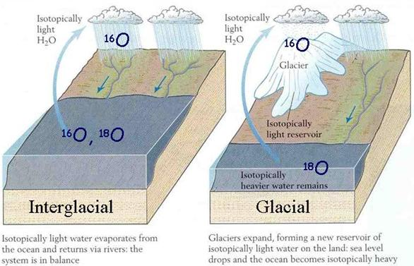
http://www.globalchange.umich.edu/gctext/Inquiries/Inquiries_by_Unit/Unit_8a.htm
http://earthobservatory.nasa.gov/Features/Paleoclimatology_OxygenBalance/oxygen_balance.php

pronounced in cold climates than in warmer ones, because temperature is what drives the evaporation/condensation processes. Snow has much more negative δ¹⁸O than rain. Since temperature drives this process, an equation has been derived to relate temperature to δ¹⁸O.
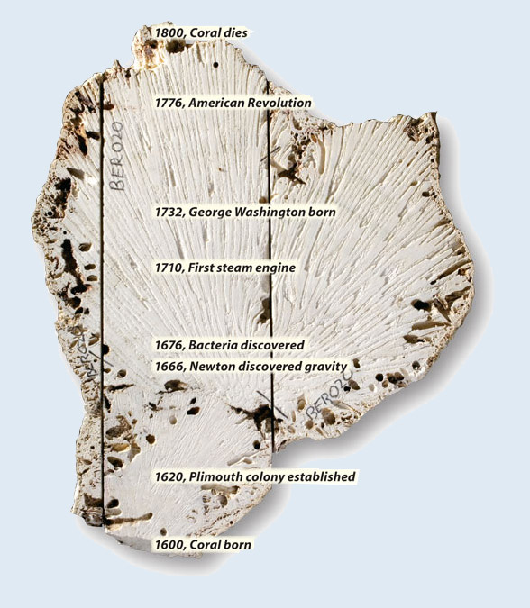

- Coral skeletons can give
scientists another clue.
Examine this photo (by
Tom Kleindinst, Woods
Hole Oceanographic
Institution).

- How long did this coral
live? 200 yrs

- How do you think scientists know
where to put the places shown in
the picture? Student answers will vary.
A slice was made through the center of the long-dead brain coral. It is a slice through human and ocean history. This 1,000-pound coral grew near Bermuda during the Little Ice Age. Radiating marks visible in the photo are grooves from the quarry saw that sliced through the coral. The coral changed its growth direction once in about 1650, and marine life eroded its surface, but scientists can analyze the coral's inner skeleton and decipher ocean temperatures during its lifespan.
While a coral is growing it incorporates a lot of uranium (U), but no thorium (Th). This means that as it ages its Th/U ratio increases at a known rate. So, measurements of the Th/U ratio provide a measurement of the coral’s age.
- Change or add to your answer from #4; How do scientists know the age of the coral and where to put the places shown in the picture? measurements of the Th/U ratio provide a measurement of the coral’s age.

- Scientists often come up with new ideas about where to obtain more clues. Click here: http://www.whoi.edu/main/topic/ice-ages-past-climates , and choose
to see how one, young researcher combined her interests in climbing and science to solve a problem.

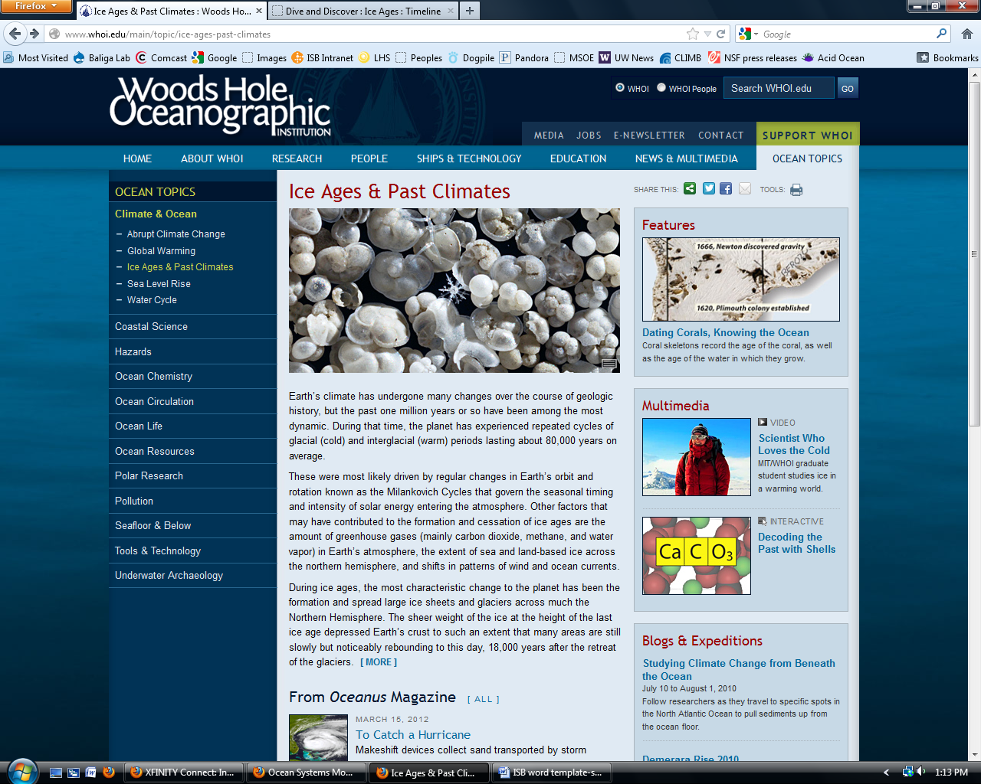

- What is the problem Ms.Criscitiello wanted to solve? What was happening to the sea ice before the advent of satellite data collection.

- Briefly describe 2 techniques she used to obtain data.
- Dug a ‘snow-pit’ to examine layers and take samples
- Drill ice cores, cut them, melt them and measure the MSA

- How does she confirm that concentrations of MSA actually can be used?
Recent layers match to the satellite data so older layers should work too.

Scientists determine that the data they collect are actually useful by checking their results with other scientists and by seeing if other types of data lead to the same conclusions. You have explored several ways scientists collect data. Using chemical information collected from ice cores and from shells of organisms preserved in deep-sea sediments, geologists have been able to map out how Earth's climate has changed over time. They need to communicate their data in such a way that others can have access to it. Graphs are commonly used for data analysis.
- Click on http://carbonconnections.bscs.org/curriculum/unit-01/lesson-02.php#emccc Scroll down to and play the animation. This will help you understand how the following graphs are produced.
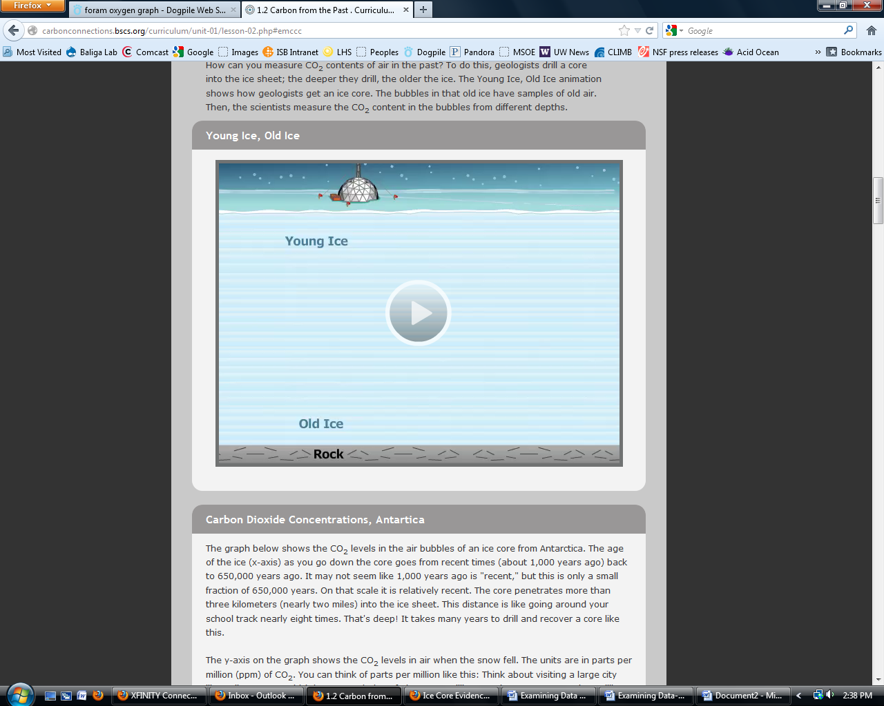

- Examine the graph below.
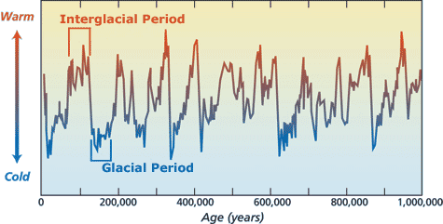

- What span of time does it cover? Fairly recent to 1 million years ago.

- What do the peaks and valleys tell you? Highest temps. and lowest temps.

- Examine the graph below.
- What is different about this graph? Shorter time span, flatter line
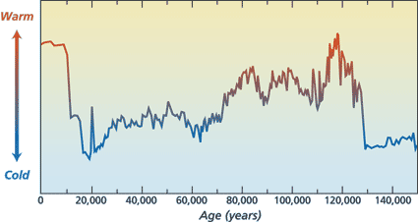
- Which time in history was
most like the current
temperature? 120,000 ya

- Compare the 10,000 years
previous to the 2 warmest
times. What is different?
Recent shows much less
fluctuation before
maximum, rapid change (shown by slope).
Let’s compare 3 different types of data in more detail. You will need a sheet of tracing paper and colored pencils or a transparency and water-based pens, a ruler, and the graphs for comparison.
- Cut out the 3 graphs and arrange them on your table so that you can easily compare the lines.

- Are all 3 graphs comparable? Yes and no. Explain. They all show change over time but are different in what was measured: oxygen, CO₂ and temperature.
- Place a sheet of transparency film or tracing paper over any graphs you are able to match up. Align them. Use a ruler and pen or pencil to draw a line over the aligned Y axes so you have made an ‘anchoring line’. Label this line.

- What do you need to do to align all of the graphs so that you can compare the data? Flip the oxygen graph over.

- Use a different color to draw a vertical band through each of the lowest points (cold, low CO₂) and if there are similar points to the left and right, include those as well.

Example:

- Explain, in detail what you did to align the data of all three graphs.
Trace the line on the back of the oxygen graph so it can be seen and then match up the Y axes.

- What is different about the information depicted by the oxygen graph compare to the CO₂ and temperature graphs?
It also shows the amount of global ice as well as the O₂ isotope ratio.

- Make a generalization about what is happening to CO₂, temperature and
oxygen isotopes over time.
They all follow a similar pattern of cycling between high and low data points. It appears that they are related to each other. (Causative? Correlation?)
- Examine the next two graphs. http://cdiac.ornl.gov/trends/co2/lawdome-graphics.html
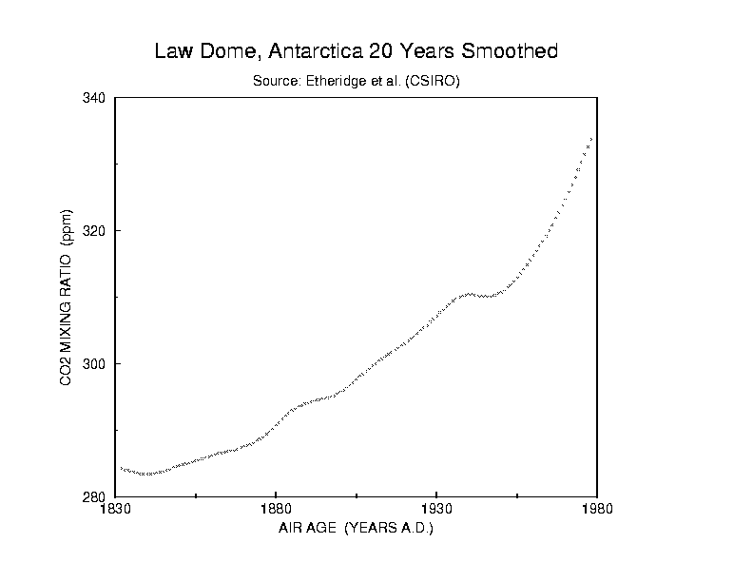
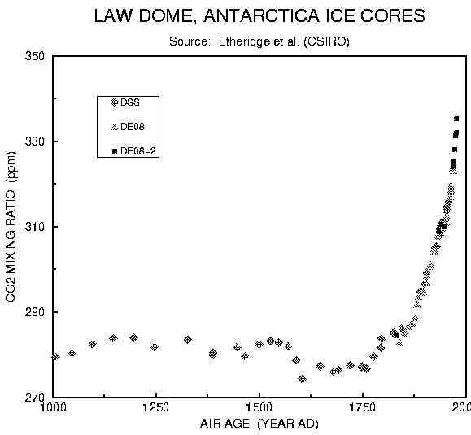
- Draw a vertical line on the 1st graph showing where the data from the 2nd graph
begins.

- Describe what the data from these 2 graphs indicate has happened since 1000AD. CO2 remained under 300ppm for 830 years and then rapidly increased to 335ppm by 1980.

- Calculate the rate of change from 1000AD to 1830AD. (show work)
ΔCO2 ÷ Δage approximately: 4 ÷ 1830 = 0.0022ppm/year
- Calculate the rate of change from 1830AD to 1980AD. (show work)
ΔCO2 ÷ Δage approximately: 50 ÷ 150 = 0.33ppm/year
- How many times faster is the rate of change from 1830 to 1980 compared to the previous time period shown? 150 times (0.33 ÷ 0.0022)
Fill in the missing information:
- I have examined 3-4__(number) lines of evidence supporting the theory that…
We are experiencing rapid climate change since the industrial revolution.
- Scientists are confident in their findings because…
The temperature and CO2 are increasing while O2 is decreasing more rapidly than during any time in the last 100,000 years.
- Which line of evidence do you find most convincing? Answers will vary…look for logical explanation.
Explain:

