Using error bars to display uncertainty in measurements is simply not done very often, and is an enormous problem in how people use and understand statistics. “Wonderful,” they’ll say, “test scores at our school went up by 15 points this year.” Well, maybe that’s good news, and maybe it’s not.
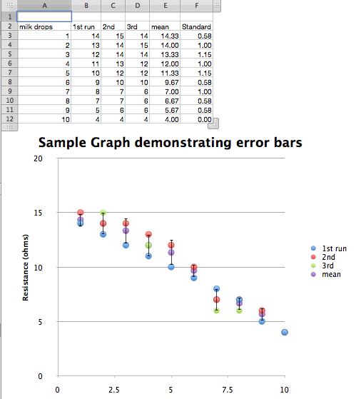
What would have happened if the same test had been given to the same students 3 days in a row? Would they have gotten exactly the same scores? Not likely. How different would they be? Are the two scores really different? That’s what an error bar tries to show.
Open the Excel sheet called “Sample Error Bar Graph”
Unfortunately, this particular feature is one that’s changed so much in various Excel versions over the years, there’s simply no way to write specific directions for how to do this.
It’s even possible that our sample spreadsheet won’t display the way we intended, depending on the versions of Excel we used, and you’re using.
But it is possible to make this, and your best source of help is, well, the help function installed with Excel. Definitely practice with it on your own, because your students will have lots of questions!
Note that we’ve tried to make the same measurement 3 times: the resistance of our photoresistor as the same light comes through a suspension of milk fat in the water in a test tube. But rarely are the measurements exactly the same.
So we’ve set up a mean (or average) column, and then made an X-Y scatter graph that has 4 points (3 actual measurements and their average) for each milk concentration.
Then, we’ve created a new column and calculated the STANDARD DEVIATION for each concentration (click on one of the cells in the spreadsheet to see the formula). STANDARD DEVIATION (SD) is a way of describing numerically how spread out a set of measurements are. It’s only useful when the size of the SD is compared to the size of the MEAN. For example, I have a set of measurements where the SD is one million. Oooh, that’s big. Well, not if the mean is one trillion trillion.
We’re going to base our error bars on our calculated SDs for this data set. In general, that’s going to involve clicking on one of the mean points in the chart you’ve already made to get to a “Format Data Series” window, then look for error bars. You’ll tell Excel to display error bars based on a custom amount, then drag over the numbers in the SD column to create formulas starting with “ =SHEET…….” for the positive AND negative error bar.
So, what does the size of the error bar mean? Roughly speaking, you can be sure, with about 95% confidence, that the “real” number lies between the error bars.
This is a vast oversimplification, and any professional statistician would be able to write a book on the errors within that last sentence, but go with it for now, and take a statistics course or 3 later.
Here’s a way to say it to your students: If 2 error bars overlap, your data isn’t good enough to convince anyone that the measurements are really seeing a difference.
In general, having more measurements of the same thing will reduce the size of the error bars, as will improving the quality of your measurements any way you can.

